# Introduction

## What is Computer Organization (or system organization)?

* How operational parts of a computer system are linked together.
* Implements provided computer architecture
* Deals with “How to do?”
* Explains how computer works
* Structural relationships between parts of a system
* Low level design

## What is Computer Architecture?

* Blueprint for design and implementation of a computer system.
* Provides functional details and behavior of a CS.
* Comes before Comp Org
* Explains what a computer should do
* High level design

## Digital concepts

* Generally associated with a computer
* Is derived from the way computers perform operation – counting digits
* Other applications now:
  + Industrial
  + Military
  + Medical
  + Radar
  + ....

## Signal concepts

* Physical quantity
* Contains information
* Function of one or more independent variables
* Two types:
  + Analog
  + Digital

### Analog Signal

* Signal having continuous values
* Infinite number of different values
* Real-world – most things in nature:
  + Temperature, pressure, distance, sound, voltage, current, power
* Circuits that process are called analog circuits or system
* Examples: filter, amplifiers, TV receiver, motor speed controller
* Disadvantages:
  + Less accuracy, less versatility, more noise effect, more distortion, more effect of weather

### Digital Signal

* Has only a finite number of distinct values
* Not continuous signals
* Input is given with help of switches
* Two distinct values – low level or high level
* Always be one of the two
* Examples: binary signal, octal signal, hex signal
* Circuits that process are called digital systems or circuits
* Examples: Registers, flip-flop, counters, microprocessors
* Advantage:
  + More accuracy, more versatility, less distortion, easy communicate, possible storage of info

## Digital Number System

* Digital system can understand positional number system
* Only where there are a few symbols – digits
* Represent different values depending on position they occupy in the number value of each digit in a number is determined by:
* The digit
  + Position of digit in number
  + Base of the number system
* Decimal number:
  + Binary – Base 2 1 / 0
  + Octal – Base 8 0 – 7
  + Hexa – Base 16 0-7 letters A-F
  + Review and review conversions too

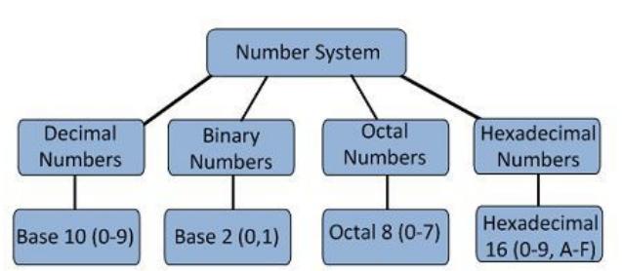

### Binary Codes

* In coding, numbers, letters or word are presented by specific group of symbols
* Called – encoded
* Groups of symbols called as a code
* Digital data is represented, stored, and transmitted as group of binary bits
* Called – binary code
* Advantages of binary code:
  + Suitable for the computer applications
  + Suitable for the digital communications
  + Allows the analysis and designing of digital circuits
  + Since 0/1 are being used – implementation is easy
* Classifications of binary codes
  + Weighted
  + Non-weighted
  + Binary Coded Decimal
  + Alphanumeric
  + Error detecting
  + Error correcting

